Control Engineering II

Handout – Online Laboratory 5

Name: *Colda Andreea Ariana*

Group: *30332*

A mathematical model of the following form has to be determined:

$H_{f}(s)=\frac{y(s)}{u(s)}=\frac{k}{Ts+1}$ = 200/(s+1)

where k and T are the process gain and time constant, respectively.

Add identified mathematical model and validation on:

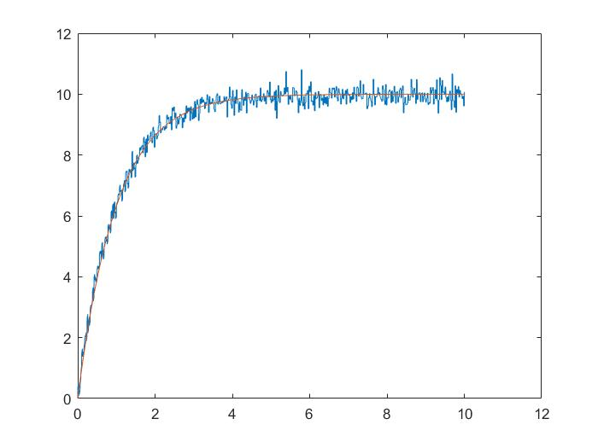

1. 0.07 input change

Add plot here

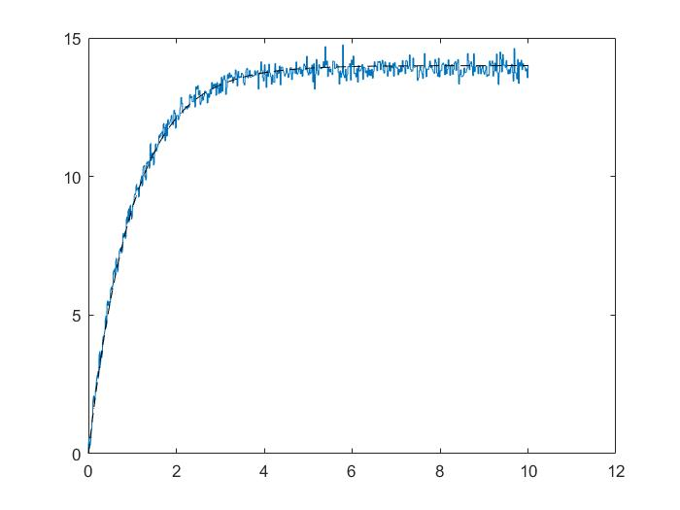

1. -0.05 input change

Add plot here

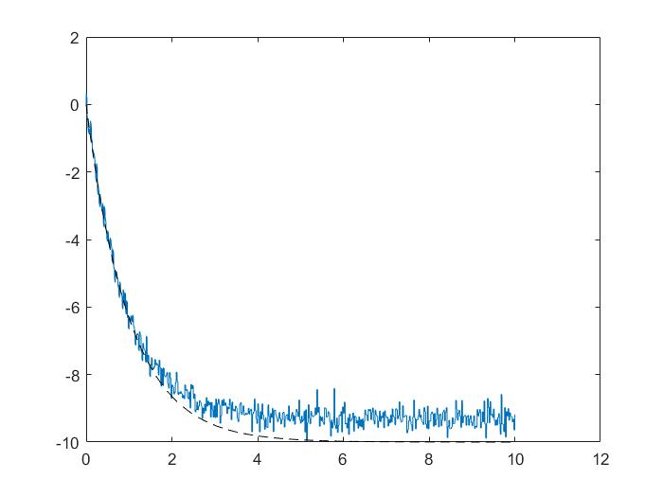

Design a controller such that the following performance specifications are met: overshoot σ = 5% and settling time ts = 1.5 s, along with a zero steady state error.

Add obtained controller – continuous time

0.074658 (s+1)

Hc = --------------

s (s+5.333)

Add obtained controller– discrete – time. Motivate the sampling time choice.

Ts = 0.002

0.00014867 (z-0.998)

Hc_discret = --------------------

(z-1) (z-0.9894)

Implement your discrete time controller in the Servo_model_ctrl.slx Simulink file and run the Simulink file to check the performance of the overall closed loop system. Determine the overshoot and settling time for each operating point (50, 55, 60, 65, 60, 55, 50, 45). Conclude upon the ability of the controller to meet the performance specifications in all operating points (robust controller or not).

Add plot

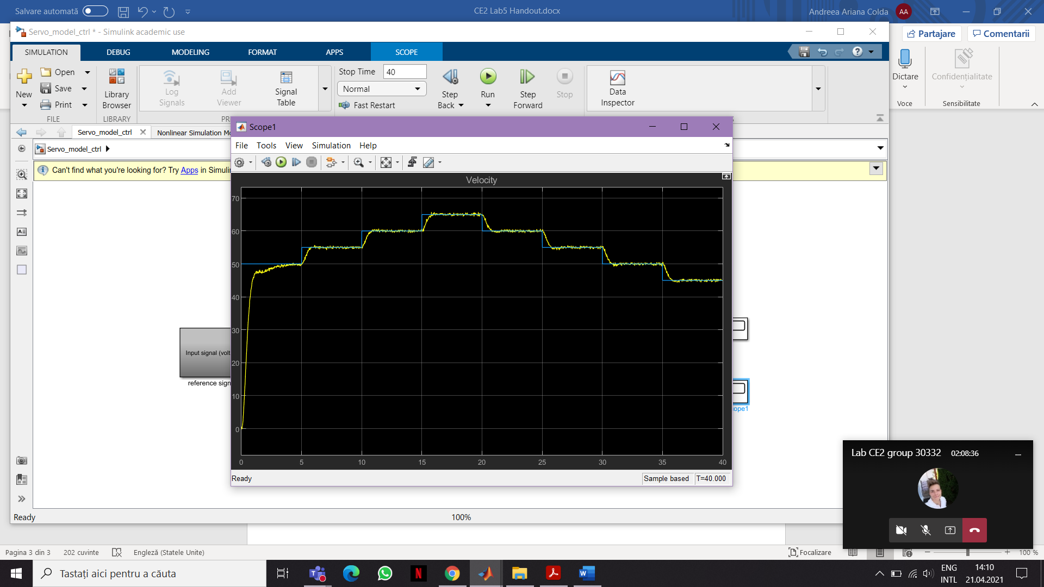

Add overshoot and settling time for the operating points

50: overshoot- 0% and ts = 4.8 sec

55: overshoot- 0% and ts = 6 sec

60: overshoot- 0% and ts = 11 sec

65: overshoot- 0% and ts = 16 sec

60: overshoot- 0% and ts = 21 sec

55: overshoot- 0% and ts = 27 sec

50: overshoot- 0% and ts = 32 sec

45: overshoot- 0% and ts = 37 sec